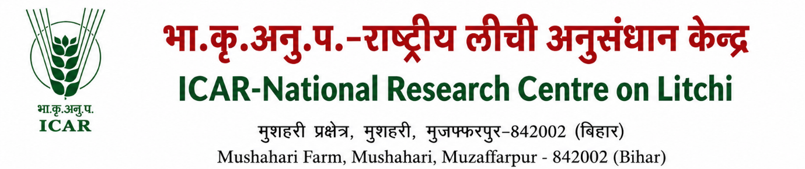
Proforma to be submitted to the director by the scientist for sending research paper /short note / success story

1 | Title | :
2 | Name(s) of the Authors | :
3 | Division / Station / Research Laboratory | :
4 | Project No. & Title | :
5 | Period covered in the study | :
6 | If not under nay project, please  mentioned whether permission  has been obtained to undertake the work | :
7 | Have all the names of Project workers been associated in the abstract | :
8 | Signature of all the authors | :
9 | To whom the abstract have  to be sent (Full address to be given) | :
10 | Recommendation of the Head  of the Division/Section | :
11 | Recommendation of the Chairman, RMCU for forwardal of abstract | :
12 | Director’s Remarks | : | Approved/Not Approved  DIRECTOR

Proforma to be submitted to the director by the scientist for sending abstracts to symposium/conference/seminar/workshop

1 | Title | :
2 | Name(s) of the Authors | :
3 | Division / Station / Research Laboratory | :
4 | Project No. & Title | :
5 | Period covered in the study | :
6 | If not under nay project, please  mentioned whether permission  has been obtained to undertake the work | :
7 | Have all the names of Project workers been associated in the abstract | :
8 | Signature of all the authors | : | 1.  2.  3.
9 | Title of the symposium / Conference / Seminar / Workshop
10 | To whom the abstract have  to be sent (Full address to be given) | :
11 | Scheduled date and place of Symposium / Conference / Seminar / Workshop
12 | The expenditure to be incurred towards attending the Symposium/Conference/Seminar  /Workshop  - Registration Fee  - Probable TA/DA:
13 | Has the Scientist attended  previously any Symposium/  Workshop/Seminar/Conference? If so, when and the other details
10 | Recommendation of the Head  of the Division/Section | :
11 | Recommendation of the Chairman, RMCU  - For forwardal of abstract  - For participation of the Seminar, etc | :
12 | Director’s Remarks | : | Approved/Not Approved  DIRECTOR

